|  |
| --- |
| **MALAYSIA TERENGGANU UNIVERSITY**  **FACULTY OF OCEAN ENGINEERING TECHNOLOGY & INFORMATICS**  **CSF3206**  **WEB-BASED USER INTERFACE DESIGN**  **Final Report**  **Prepared by:**  Group No. 9  AMEERUL ISKANDAR BIN ABDULLAH (S57810)  UMMU AQILAH BINTI ZULKEFLI (S60150)  SITI NUR HANISAH BINTI SHA’ARI (S58698)  NURUL IZZAH BINTI ABDULLAH (S59330)  **Prepared for:**  CIK FATIMAH BINTI MAMAT  [SARJANA MUDA SAINS KOMPUTER (KEJURUTERAAN PERISIAN) DENGAN KEPUJIAN]  SEMESTER I 2021/2022 |

**TABLE OF CONTENTS**

|  |  |  |
| --- | --- | --- |
| **NO.** | **INDEX** | **PAGES** |
| **1** | **ROLES AND RESPONSIBILITIES** | **3** |
| **2** | **INTRODUCTION**   * **Problem Statements** * **Objective Of The Project** * **Scope Of The Project** * **Limitations And Weakness Of The Project** * **Benefits Of The Project** * **Potential Risk Of The Project** | **4** |
| **3** | **REQUIREMENT ANALYSIS**   * **Design Objectives** * **Functional Requirement** * **Non-Functional Requirement** * **Constraints And Limitations On The Design Problem** | **5** |
| **4** | **WEB DESIGN**   * **Site-Map : Hierarchy** * **Wireframe** | **6** |
| **5** | **USER INTERFACE DESIGN** | **7** |
| **6** | **CONCLUSION** | **12** |
| **7** | **APPENDIX**   * **HTML Source Code** * **CSS Source Code** | **13**  **53** |
| **8** | **REFERENCES** | **58** |

**ROLES & RESPONSIBILITIES**

|  |  |  |
| --- | --- | --- |
| **Student ID** | **Name** | **Roles** |
| **S57810** | **Ameerul Iskandar Bin Abdullah** | 1. **Find the intended audiences** 2. **Brainstorming the issues or problems our site might face** 3. **Create the goals of the website** 4. **Figure out working title** |
| **S60150** | **Ummu Aqilah Binti Zulkefli** | 1. **Listing 2 related or similar site on the web** 2. **Figure out the information needed** 3. **Brainstorming the sources to obtain the content** 4. **Listing out the requirement analysis** |
| **S58698** | **Siti Nur Hanisah Binti Sha’ari** | 1. **Developing Site Map** 2. **Finding the purpose of the project** 3. **Create the goals of the project** 4. **Developing the html sources, css sources and javascript** |
| **S59330** | **Nurul Izzah Binti Abdullah** | 1. **Developing Wireframe** 2. **Search for the type of content** 3. **Developing web-design** 4. **List out the contents for introduction** |

1. **INTRODUCTION**
   1. **Problem Statements**

There are a variety of cats in the world. Besides that, there are also many different ways to take care of each breed of cats. Some ways of taking care of cats may be suitable for some breeds of cats but some may not be suitable. Many ways to take care of cats may be slightly the same with each other. Because of this, many cat keepers may get the wrong information about what is suitable for their cats.

* 1. **Objective of the project**
* To help the user to gain the right information of the cats breed
* To help the user to differentiate the cats breed easily
* To show the variety of cats’ breed.
  1. **Scope of the project**
* Only the admin of the website can have the access to the website to change the information of the cats’ breed
* The visitor can choose the cat's breed on the website to access the information of the cats’ breed.
  1. **Limitations and weakness of the project**
* The website can only display a few cats’ breed
* The information given is limited and lacked
* The website cannot do a filtration based on the size, coat, shedding, and energy.
  1. **Benefits of the project**
* Can help the cats keeper to get the right information about their cats
* Can help the cats keeper to differentiate between cats’ breed
* Can show the variety of cats’ breed

* 1. **Potential risk of the project**
* Cost. To improve the website, the cost will increase and may exceed the budget.
* Maintenance. From time to time the visitor will want more information and function provided in the website. Therefore, the admin needs to do maintenance regularly.

1. **REQUIREMENT ANALYSIS**

**2.1** **Design objectives**

* The website includes a photograph of each cat breed to help users distinguish between them physically.
* The website's interface was created to be simple and softcore, allowing users to navigate the site with ease.
* To attract users to our website, we employ the hue purple violet as a basis.

**2.2 Functional requirement**

* The website will include information about cats and their varied breeds, such as their behaviour, morphological characteristics, and other topics.
* The website will provide breed-specific information on cats.
* This website allows users to search for certain cats that they are interested in.

**2.3 Non-Functional requirement**

* This website is accessible to all users, regardless of their age, gender, or geographic location.
* This website is available at all times.
* Any browser, including Google, Internet Explorer, Mozilla Fireworks, and others, can visit this website.

**2.4** **Constraints and limitations on the design problem**

* The website only covered a certain breed of cat and did not go into great detail about the material.
* The website exclusively features the most recent cat breeds that are already well-known to the general public.
* The information about the cats and their breeds is based only on web research and is not guaranteed to be correct.

1. **WEB DESIGN**
   1. Site Map

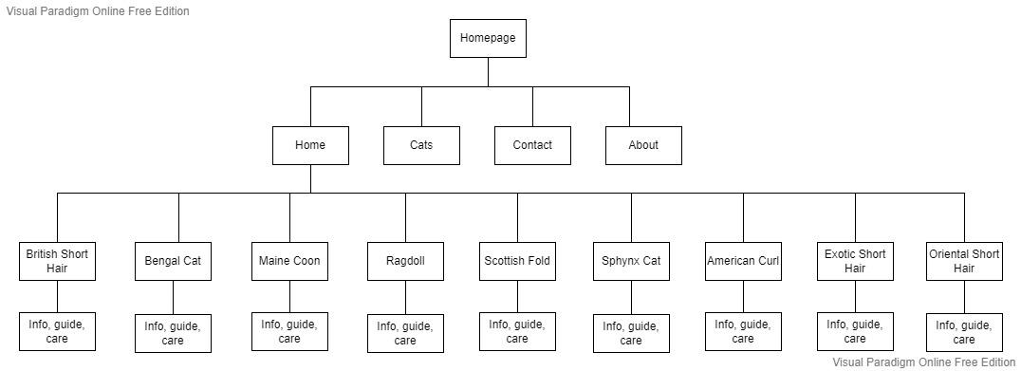

* 1. Wireframe



1. **USER INTERFACE DESIGN** 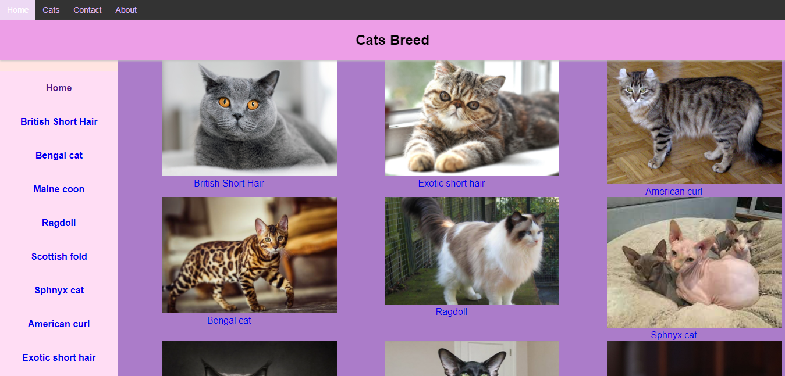

This is the main page of the interface, which displays several cat breeds and their pictures. Users may click the name of a cat under its photo on the main page, and it will take them to that cat's page.

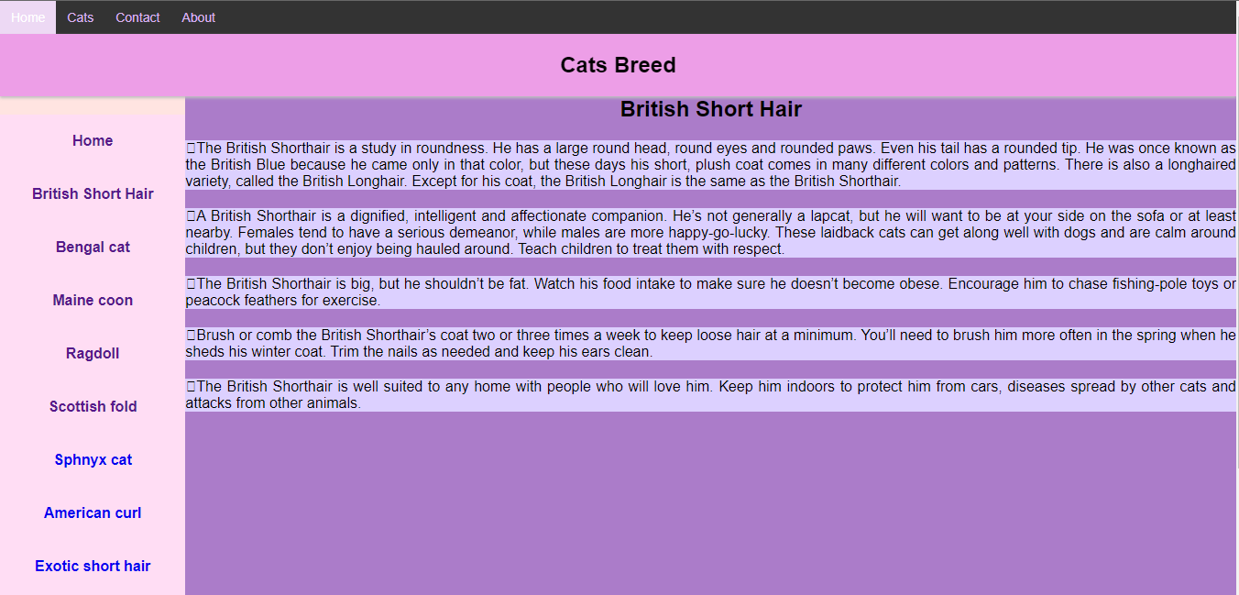

In this page, user can view details and information about British Short Hair cat.

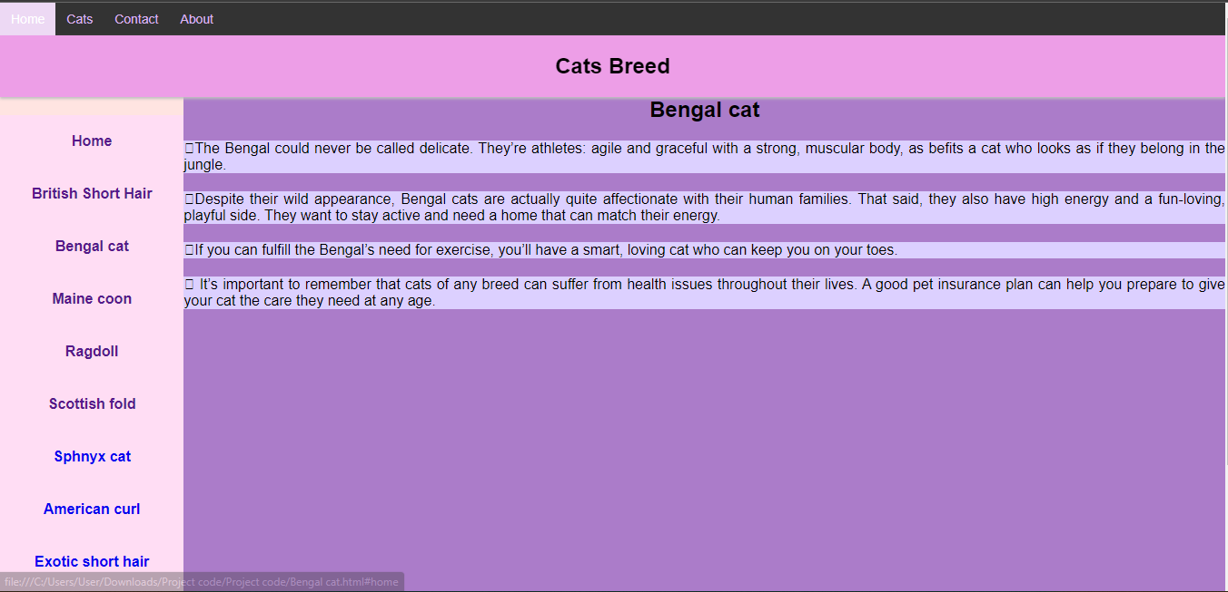

In this page, user can view details and information about Bengal cat.

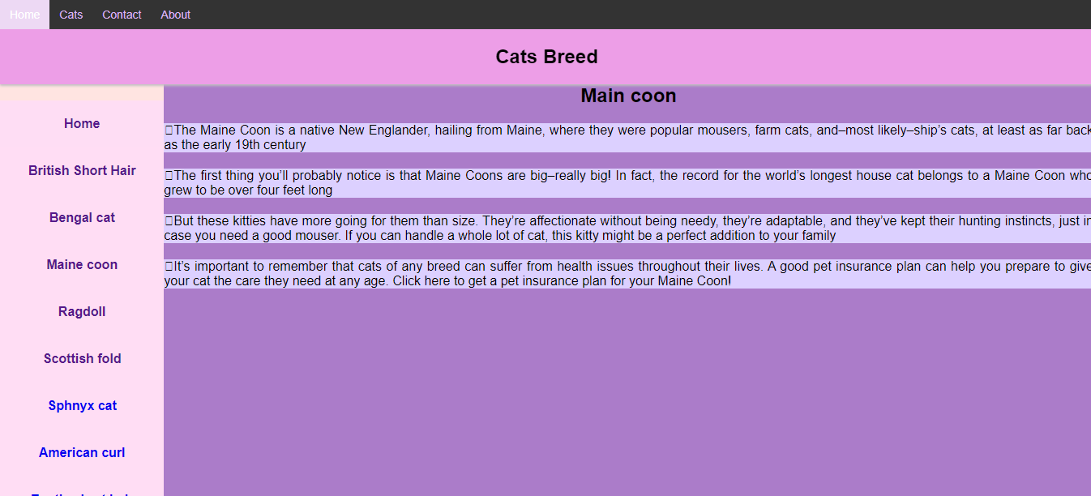

In this page, user can view details and information about Maine Coon cat.

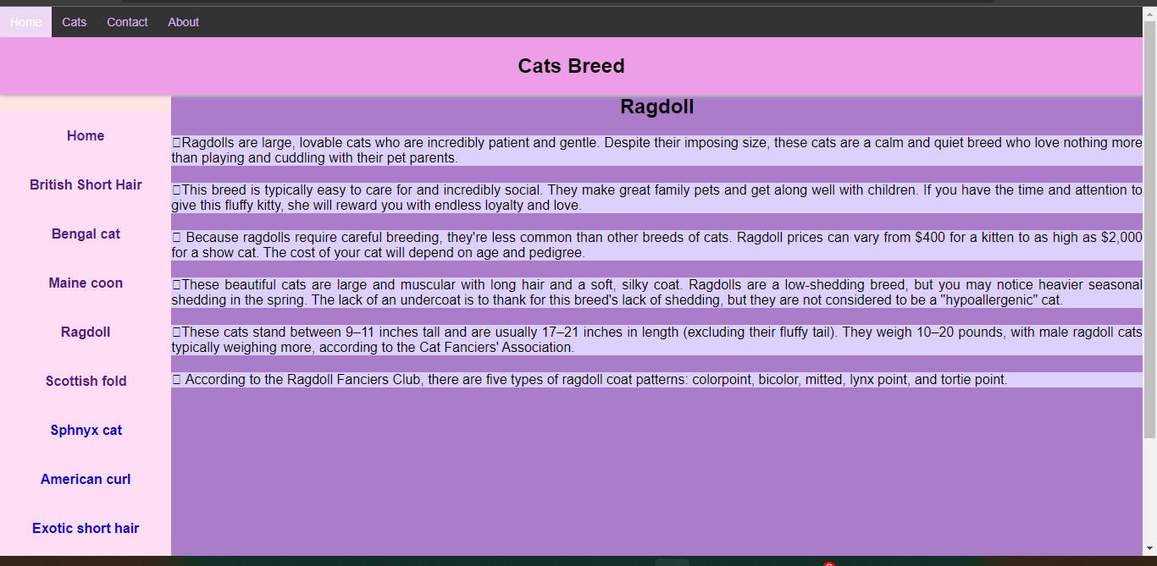

In this page, user can view details and information about Ragdoll cat.

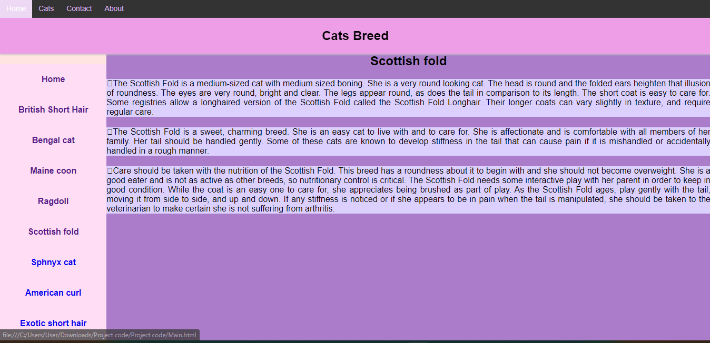

In this page, user can view details and information about Scottish Fold cat.

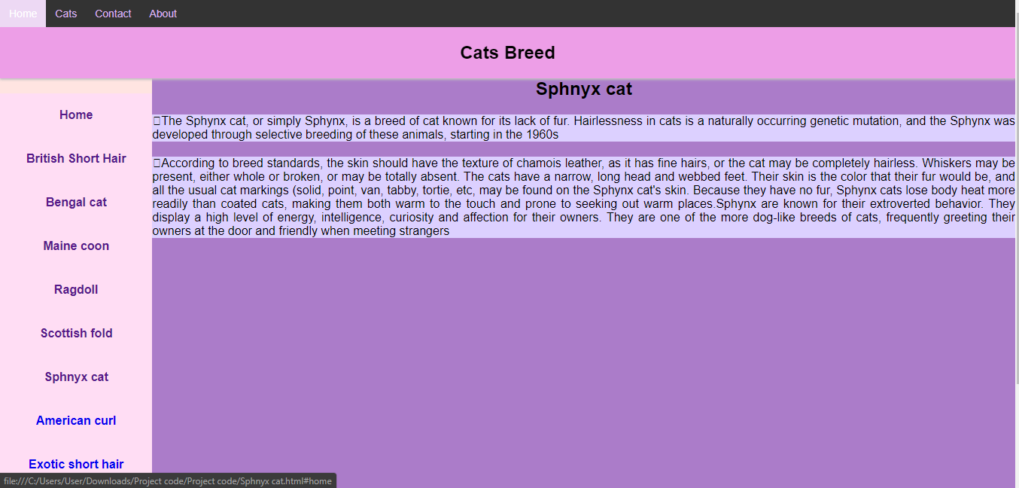

In this page, user can view details and information about Sphnyx cat.

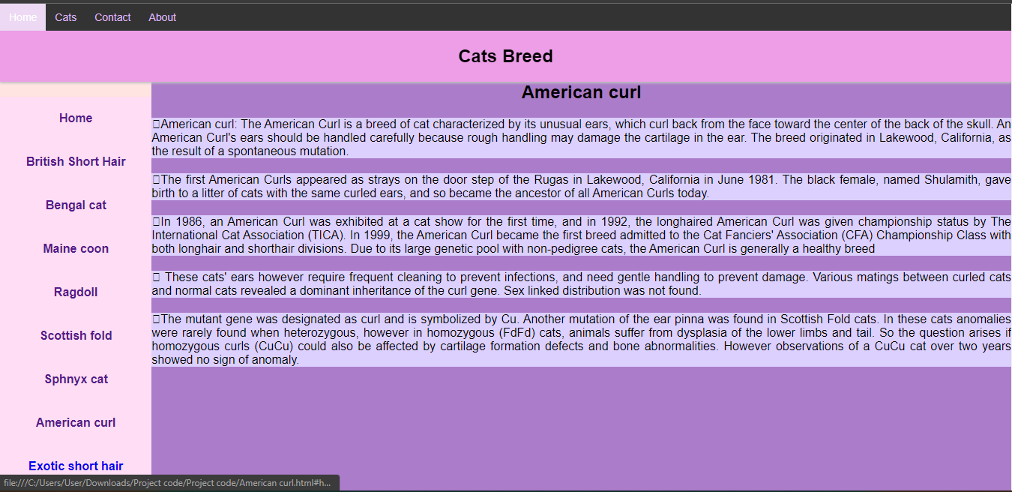

In this page, user can view details and information about American Curl cat.

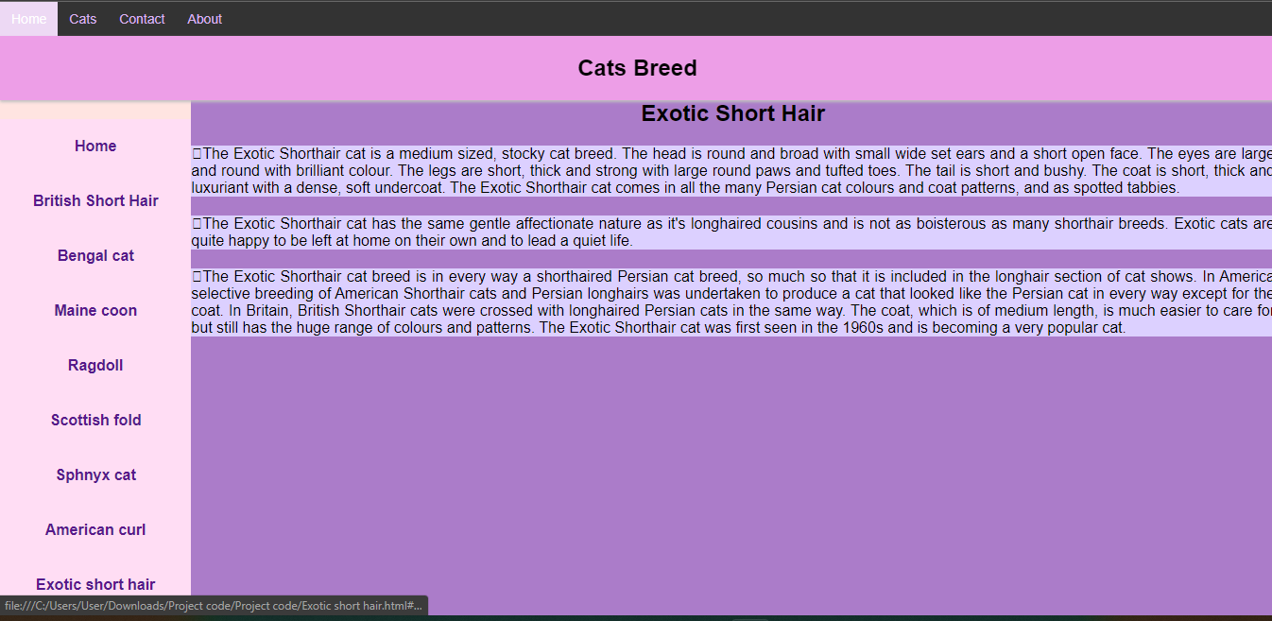

In this page, user can view details and information about Exotic Short Hair cat.

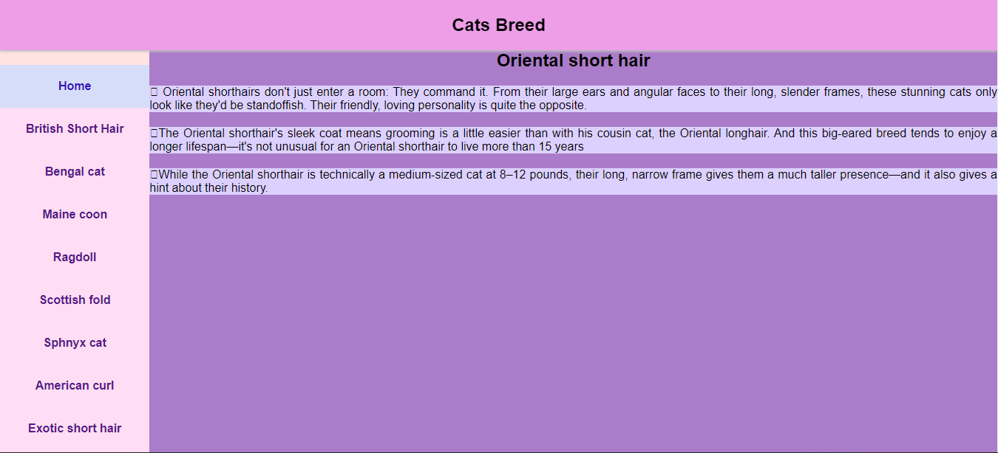

In this page, user can view details and information about Oriental Short Hair cat.

1. **CONCLUSION**

Animal husbandry has grown fashionable, and many people prefer cats as pets because of their sociability and cuteness. Cats are said to be able to relieve stress and improve the health of their owners, in addition to being kept as pets. As a result of today's technology, cat-related websites have been built to satisfy those who wish to pick their favourite cat based on their tastes.

1. **APPENDIX**
   1. **HTML5 Source code**

**6.1.1 Main html**

<!DOCTYPE html>

<html>

<head>

<meta name="viewport" content="width=device-width, initial-scale=1">

<style>

.topnav {

overflow: hidden;

background-color: #333;

}

.topnav a {

float: left;

color: #DAB5F2;

text-align: center;

padding: 10px 12px;

text-decoration: none;

font-size: 14px;

}

.topnav a:hover {

background-color: #BF7AD6 ;

color:#2631CC;

}

.topnav a.active {

background-color: #EDD9F4;

color: white;

}

</style>

<title>Cats Breed</title>

<!--internal css--->

<style type="text/css">

*{

margin: 0;

padding: 0;

font-family: sans-serif;

box-sizing: border-box;

text-decoration:none;

}

</style>

<link rel="stylesheet" type="text/css" href="project.css">

<!--external css--->

</head>

<body>

<div class="topnav">

<a class="active" href="#home">Home</a>

<a href="#news">Cats</a>

<a href="#contact">Contact</a>

<a href="#about">About</a>

</div>

<section class="header">

<h1>Cats Breed</h1>

</section>

<div class="main">

<section class="left">

<!--left section--->

<a href="Main.html">Home</a>

<a href="British Short Hair.html">British Short Hair</a>

<a href="Bengal cat.html">Bengal cat</a>

<a href="Maine coon.html">Maine coon</a>

<a href="Ragdoll.html">Ragdoll</a>

<a href="Scottish fold.html">Scottish fold</a>

<a href="Sphnyx cat.html">Sphynx cat</a>

<a href="American curl.html">American curl</a>

<a href="Exotic short hair.html">Exotic short hair</a>

<a href="Oriental short hair.html">Oriental short hair</a>

</section>

<section class="right">

<!-- right section--->

<div id="banner" style="overflow: hidden; display: flex; justify-content:space-around;">

<div class="" style="max-width: 20%; max-height: 20%;">

<img src ="british shorthair.jpg">

<a href="British Short Hair.html">British Short Hair</a>

</div>

<div class="" style="max-width: 20%; max-height: 100%;">

<img src ="exotic shorthair.jpg">

<a href="Exotic short hair.html">Exotic short hair</a>

</div>

<div class="" style="max-width: 20%; max-height: 20%;">

<img src ="American curl.jpg">

<a href="American curl.html">American curl</a>

</div>

</div>

<div id="banner" style="overflow: hidden; display: flex; justify-content:space-around;">

<div class="" style="max-width: 20%; max-height: 20%;">

<img src ="Bengal.jpg">

<a href="Bengal cat.html">Bengal cat</a>

</div>

<div class="" style="max-width: 20%; max-height: 100%;">

<img src ="Ragdoll.jpg">

<a href="Ragdoll.html">Ragdoll</a>

</div>

<div class="" style="max-width: 20%; max-height: 20%;">

<img src ="sphynx cat.jpg">

<a href="Sphnyx cat.html">Sphnyx cat</a>

</div>

</div>

<div id="banner" style="overflow: hidden; display: flex; justify-content:space-around;">

<div class="" style="max-width: 20%; max-height: 20%;">

<img src ="maine coon.jpg">

<a href="Maine coon.html">Maine coon</a>

</div>

<div class="" style="max-width: 20%; max-height: 100%;">

<img src ="oriental shorthair.jpg">

<a href="Oriental short hair.html">Oriental short hair</a>

</div>

<div class="" style="max-width: 20%; max-height: 20%;">

<img src ="scottish fold.jpg">

<a href="Scottish fold.html">Scottish fold</a>

</div>

</div>

</section>

</div>

<section class="footer">

<p>Copyright</p>

<p>2022</p>

</section>

</body>

</html>

**6.1.2 British Short hair html**

<!DOCTYPE html>

<html>

<head>

<meta name="viewport" content="width=device-width, initial-scale=1">

<style>

.topnav {

overflow: hidden;

background-color: #333;

}

.topnav a {

float: left;

color: #DAB5F2;

text-align: center;

padding: 10px 12px;

text-decoration: none;

font-size: 14px;

}

.topnav a:hover {

background-color: #BF7AD6 ;

color:#2631CC;

}

.topnav a.active {

background-color: #EDD9F4;

color: white;

}

</style>

<title>Cats Breed</title>

<!--internal css--->

<style type="text/css">

*{

margin: 0;

padding: 0;

font-family: sans-serif;

box-sizing: border-box;

text-decoration:none;

}

</style>

<link rel="stylesheet" type="text/css" href="project.css">

<!--external css--->

</head>

<body>

<div class="topnav">

<a class="active" href="#home">Home</a>

<a href="#news">Cats</a>

<a href="#contact">Contact</a>

<a href="#about">About</a>

</div>

<section class="header">

<h1>Cats Breed</h1>

</section>

<div class="main">

<section class="left">

<!--left section--->

<a href="Main.html">Home</a>

<a href="British Short Hair.html">British Short Hair</a>

<a href="Bengal cat.html">Bengal cat</a>

<a href="Maine coon.html">Maine coon</a>

<a href="Ragdoll.html">Ragdoll</a>

<a href="Scottish fold.html">Scottish fold</a>

<a href="Sphnyx cat.html">Sphynx cat</a>

<a href="American curl.html">American curl</a>

<a href="Exotic short hair.html">Exotic short hair</a>

<a href="Oriental short hair.html">Oriental short hair</a>

</section>

<section class="right">

<!-- right section--->

<h2> British Short Hair</h2>

<p>The British Shorthair is a study in roundness. He has a large round head, round eyes and rounded paws. Even his tail has a rounded tip. He was once known as the British Blue because he came only in that color, but these days his short, plush coat comes in many different colors and patterns. There is also a longhaired variety, called the British Longhair. Except for his coat, the British Longhair is the same as the British Shorthair.</p>

<p>A British Shorthair is a dignified, intelligent and affectionate companion. He’s not generally a lapcat, but he will want to be at your side on the sofa or at least nearby. Females tend to have a serious demeanor, while males are more happy-go-lucky. These laid back cats can get along well with dogs and are calm around children, but they don’t enjoy being hauled around. Teach children to treat them with respect.</p>

<p>The British Shorthair is big, but he shouldn’t be fat. Watch his food intake to make sure he doesn’t become obese. Encourage him to chase fishing-pole toys or peacock feathers for exercise.</p>

<p>Brush or comb the British Shorthair’s coat two or three times a week to keep loose hair at a minimum. You’ll need to brush him more often in the spring when he sheds his winter coat. Trim the nails as needed and keep his ears clean.</p>

<p>The British Shorthair is well suited to any home with people who will love him. Keep him indoors to protect him from cars, diseases spread by other cats and attacks from other animals.</p>

</section>

</div>

<section class="footer">

<p>Copyright</p>

<p>2022</p>

</section>

</body>

</html>

**6.1.3 Bengal cat html**

<!DOCTYPE html>

<html>

<head>

<meta name="viewport" content="width=device-width, initial-scale=1">

<style>

.topnav {

overflow: hidden;

background-color: #333;

}

.topnav a {

float: left;

color: #DAB5F2;

text-align: center;

padding: 10px 12px;

text-decoration: none;

font-size: 14px;

}

.topnav a:hover {

background-color: #BF7AD6 ;

color:#2631CC;

}

.topnav a.active {

background-color: #EDD9F4;

color: white;

}

</style>

<title>Cats Breed</title>

<!--internal css--->

<style type="text/css">

*{

margin: 0;

padding: 0;

font-family: sans-serif;

box-sizing: border-box;

text-decoration:none;

}

</style>

<link rel="stylesheet" type="text/css" href="project.css">

<!--external css--->

</head>

<body>

<div class="topnav">

<a class="active" href="#home">Home</a>

<a href="#news">Cats</a>

<a href="#contact">Contact</a>

<a href="#about">About</a>

</div>

<section class="header">

<h1>Cats Breed</h1>

</section>

<div class="main">

<section class="left">

<!--left section--->

<a href="Main.html">Home</a>

<a href="British Short Hair.html">British Short Hair</a>

<a href="Bengal cat.html">Bengal cat</a>

<a href="Maine coon.html">Maine coon</a>

<a href="Ragdoll.html">Ragdoll</a>

<a href="Scottish fold.html">Scottish fold</a>

<a href="Sphnyx cat.html">Sphynx cat</a>

<a href="American curl.html">American curl</a>

<a href="Exotic short hair.html">Exotic short hair</a>

<a href="Oriental short hair.html">Oriental short hair</a>

</section>

<section class="right">

<!-- right section--->

<h2> Bengal cat</h2>

<p>The Bengal could never be called delicate. They’re athletes: agile and graceful with a strong, muscular body, as befits a cat who looks as if they belong in the jungle.</p>

<p>Despite their wild appearance, Bengal cats are actually quite affectionate with their human families. That said, they also have high energy and a fun-loving, playful side. They want to stay active and need a home that can match their energy.</p>

<p>If you can fulfill the Bengal’s need for exercise, you’ll have a smart, loving cat who can keep you on your toes.</p>

<p> It’s important to remember that cats of any breed can suffer from health issues throughout their lives. A good pet insurance plan can help you prepare to give your cat the care they need at any age.</p>

</section>

</div>

<section class="footer">

<p>Copyright</p>

<p>2022</p>

</section>

</body>

</html>

**6.1.4 Maine coon html**

<!DOCTYPE html>

<html>

<head>

<meta name="viewport" content="width=device-width, initial-scale=1">

<style>

.topnav {

overflow: hidden;

background-color: #333;

}

.topnav a {

float: left;

color: #DAB5F2;

text-align: center;

padding: 10px 12px;

text-decoration: none;

font-size: 14px;

}

.topnav a:hover {

background-color: #BF7AD6 ;

color:#2631CC;

}

.topnav a.active {

background-color: #EDD9F4;

color: white;

}

</style>

<title>Cats Breed</title>

<!--internal css--->

<style type="text/css">

*{

margin: 0;

padding: 0;

font-family: sans-serif;

box-sizing: border-box;

text-decoration:none;

}

</style>

<link rel="stylesheet" type="text/css" href="project.css">

<!--external css--->

</head>

<body>

<div class="topnav">

<a class="active" href="#home">Home</a>

<a href="#news">Cats</a>

<a href="#contact">Contact</a>

<a href="#about">About</a>

</div>

<section class="header">

<h1>Cats Breed</h1>

</section>

<div class="main">

<section class="left">

<!--left section--->

<a href="Main.html">Home</a>

<a href="British Short Hair.html">British Short Hair</a>

<a href="Bengal cat.html">Bengal cat</a>

<a href="Maine coon.html">Maine coon</a>

<a href="Ragdoll.html">Ragdoll</a>

<a href="Scottish fold.html">Scottish fold</a>

<a href="Sphnyx cat.html">Sphynx cat</a>

<a href="American curl.html">American curl</a>

<a href="Exotic short hair.html">Exotic short hair</a>

<a href="Oriental short hair.html">Oriental short hair</a>

</section>

<section class="right">

<!-- right section--->

<h2> Main coon</h2>

<p>The Maine Coon is a native New Englander, hailing from Maine, where they were popular mousers, farm cats, and–most likely–ship’s cats, at least as far back as the early 19th century</p>

<p>The first thing you’ll probably notice is that Maine Coons are big–really big! In fact, the record for the world’s longest house cat belongs to a Maine Coon who grew to be over four feet long</p>

<p>But these kitties have more going for them than size. They’re affectionate without being needy, they’re adaptable, and they’ve kept their hunting instincts, just in case you need a good mouser. If you can handle a whole lot of cat, this kitty might be a perfect addition to your family</p>

<p>It’s important to remember that cats of any breed can suffer from health issues throughout their lives. A good pet insurance plan can help you prepare to give your cat the care they need at any age. Click here to get a pet insurance plan for your Maine Coon!</p>

</section>

</div>

<section class="footer">

<p>Copyright</p>

<p>2022</p>

</section>

</body>

</html>

**6.1.5 Ragdoll**

<!DOCTYPE html>

<html>

<head>

<meta name="viewport" content="width=device-width, initial-scale=1">

<style>

.topnav {

overflow: hidden;

background-color: #333;

}

.topnav a {

float: left;

color: #DAB5F2;

text-align: center;

padding: 10px 12px;

text-decoration: none;

font-size: 14px;

}

.topnav a:hover {

background-color: #BF7AD6 ;

color:#2631CC;

}

.topnav a.active {

background-color: #EDD9F4;

color: white;

}

</style>

<title>Cats Breed</title>

<!--internal css--->

<style type="text/css">

*{

margin: 0;

padding: 0;

font-family: sans-serif;

box-sizing: border-box;

text-decoration:none;

}

</style>

<link rel="stylesheet" type="text/css" href="project.css">

<!--external css--->

</head>

<body>

<div class="topnav">

<a class="active" href="#home">Home</a>

<a href="#news">Cats</a>

<a href="#contact">Contact</a>

<a href="#about">About</a>

</div>

<section class="header">

<h1>Cats Breed</h1>

</section>

<div class="main">

<section class="left">

<!--left section--->

<a href="Main.html">Home</a>

<a href="British Short Hair.html">British Short Hair</a>

<a href="Bengal cat.html">Bengal cat</a>

<a href="Maine coon.html">Maine coon</a>

<a href="Ragdoll.html">Ragdoll</a>

<a href="Scottish fold.html">Scottish fold</a>

<a href="Sphnyx cat.html">Sphynx cat</a>

<a href="American curl.html">American curl</a>

<a href="Exotic short hair.html">Exotic short hair</a>

<a href="Oriental short hair.html">Oriental short hair</a>

</section>

<section class="right">

<!-- right section--->

<h2> Ragdoll</h2>

<p>Ragdolls are large, lovable cats who are incredibly patient and gentle. Despite their imposing size, these cats are a calm and quiet breed who love nothing more than playing and cuddling with their pet parents.</p>

<p>This breed is typically easy to care for and incredibly social. They make great family pets and get along well with children. If you have the time and attention to give this fluffy kitty, she will reward you with endless loyalty and love.</p>

<p> Because ragdolls require careful breeding, they're less common than other breeds of cats. Ragdoll prices can vary from $400 for a kitten to as high as $2,000 for a show cat. The cost of your cat will depend on age and pedigree.</p>

<p>These beautiful cats are large and muscular with long hair and a soft, silky coat. Ragdolls are a low-shedding breed, but you may notice heavier seasonal shedding in the spring. The lack of an undercoat is to thank for this breed's lack of shedding, but they are not considered to be a "hypoallergenic" cat.</p>

<p>These cats stand between 9–11 inches tall and are usually 17–21 inches in length (excluding their fluffy tail). They weigh 10–20 pounds, with male ragdoll cats typically weighing more, according to the Cat Fanciers' Association.</p>

<p> According to the Ragdoll Fanciers Club, there are five types of ragdoll coat patterns: colorpoint, bicolor, mitted, lynx point, and tortie point.</p>

</section>

</div>

<section class="footer">

<p>Copyright</p>

<p>2022</p>

</section>

</body>

</html>

**6.1.6 Scottish fold html**

<!DOCTYPE html>

<html>

<head>

<meta name="viewport" content="width=device-width, initial-scale=1">

<style>

.topnav {

overflow: hidden;

background-color: #333;

}

.topnav a {

float: left;

color: #DAB5F2;

text-align: center;

padding: 10px 12px;

text-decoration: none;

font-size: 14px;

}

.topnav a:hover {

background-color: #BF7AD6 ;

color:#2631CC;

}

.topnav a.active {

background-color: #EDD9F4;

color: white;

}

</style>

<title>Cats Breed</title>

<!--internal css--->

<style type="text/css">

*{

margin: 0;

padding: 0;

font-family: sans-serif;

box-sizing: border-box;

text-decoration:none;

}

</style>

<link rel="stylesheet" type="text/css" href="project.css">

<!--external css--->

</head>

<body>

<div class="topnav">

<a class="active" href="#home">Home</a>

<a href="#news">Cats</a>

<a href="#contact">Contact</a>

<a href="#about">About</a>

</div>

<section class="header">

<h1>Cats Breed</h1>

</section>

<div class="main">

<section class="left">

<!--left section--->

<a href="Main.html">Home</a>

<a href="British Short Hair.html">British Short Hair</a>

<a href="Bengal cat.html">Bengal cat</a>

<a href="Maine coon.html">Maine coon</a>

<a href="Ragdoll.html">Ragdoll</a>

<a href="Scottish fold.html">Scottish fold</a>

<a href="Sphnyx cat.html">Sphynx cat</a>

<a href="American curl.html">American curl</a>

<a href="Exotic short hair.html">Exotic short hair</a>

<a href="Oriental short hair.html">Oriental short hair</a>

</section>

<section class="right">

<!-- right section--->

<h2>Scottish fold</h2>

<p>The Scottish Fold is a medium-sized cat with medium sized boning. She is a very round looking cat. The head is round and the folded ears heighten that illusion of roundness. The eyes are very round, bright and clear. The legs appear round, as does the tail in comparison to its length. The short coat is easy to care for. Some registries allow a longhaired version of the Scottish Fold called the Scottish Fold Longhair. Their longer coats can vary slightly in texture, and require regular care.</p>

<p>The Scottish Fold is a sweet, charming breed. She is an easy cat to live with and to care for. She is affectionate and is comfortable with all members of her family. Her tail should be handled gently. Some of these cats are known to develop stiffness in the tail that can cause pain if it is mishandled or accidentally handled in a rough manner.</p>

<p>Care should be taken with the nutrition of the Scottish Fold. This breed has a roundness about it to begin with and she should not become overweight. She is a good eater and is not as active as other breeds, so nutritionary control is critical. The Scottish Fold needs some interactive play with her parent in order to keep in good condition. While the coat is an easy one to care for, she appreciates being brushed as part of play. As the Scottish Fold ages, play gently with the tail, moving it from side to side, and up and down. If any stiffness is noticed or if she appears to be in pain when the tail is manipulated, she should be taken to the veterinarian to make certain she is not suffering from arthritis.</p>

</section>

</div>

<section class="footer">

<p>Copyright</p>

<p>2022</p>

</section>

</body>

</html>

**6.1.7 Sphnyx cat html**

<!DOCTYPE html>

<html>

<head>

<meta name="viewport" content="width=device-width, initial-scale=1">

<style>

.topnav {

overflow: hidden;

background-color: #333;

}

.topnav a {

float: left;

color: #DAB5F2;

text-align: center;

padding: 10px 12px;

text-decoration: none;

font-size: 14px;

}

.topnav a:hover {

background-color: #BF7AD6 ;

color:#2631CC;

}

.topnav a.active {

background-color: #EDD9F4;

color: white;

}

</style>

<title>Cats Breed</title>

<!--internal css--->

<style type="text/css">

*{

margin: 0;

padding: 0;

font-family: sans-serif;

box-sizing: border-box;

text-decoration:none;

}

</style>

<link rel="stylesheet" type="text/css" href="project.css">

<!--external css--->

</head>

<body>

<div class="topnav">

<a class="active" href="#home">Home</a>

<a href="#news">Cats</a>

<a href="#contact">Contact</a>

<a href="#about">About</a>

</div>

<section class="header">

<h1>Cats Breed</h1>

</section>

<div class="main">

<section class="left">

<!--left section--->

<a href="Main.html">Home</a>

<a href="British Short Hair.html">British Short Hair</a>

<a href="Bengal cat.html">Bengal cat</a>

<a href="Maine coon.html">Maine coon</a>

<a href="Ragdoll.html">Ragdoll</a>

<a href="Scottish fold.html">Scottish fold</a>

<a href="Sphnyx cat.html">Sphynx cat</a>

<a href="American curl.html">American curl</a>

<a href="Exotic short hair.html">Exotic short hair</a>

<a href="Oriental short hair.html">Oriental short hair</a>

</section>

<section class="right">

<!-- right section--->

<h2> Sphynx cat</h2>

<p>The Sphynx cat, or simply Sphynx, is a breed of cat known for its lack of fur. Hairlessness in cats is a naturally occurring genetic mutation, and the Sphynx was developed through selective breeding of these animals, starting in the 1960s</p>

<p>According to breed standards, the skin should have the texture of chamois leather, as it has fine hairs, or the cat may be completely hairless. Whiskers may be present, either whole or broken, or may be totally absent. The cats have a narrow, long head and webbed feet. Their skin is the color that their fur would be, and all the usual cat markings (solid, point, van, tabby, tortie, etc, may be found on the Sphynx cat's skin. Because they have no fur, Sphynx cats lose body heat more readily than coated cats, making them both warm to the touch and prone to seeking out warm places.Sphynx are known for their extroverted behavior. They display a high level of energy, intelligence, curiosity and affection for their owners. They are one of the more dog-like breeds of cats, frequently greeting their owners at the door and friendly when meeting strangers</p>

</section>

</div>

<section class="footer">

<p>Copyright</p>

<p>2022</p>

</section>

</body>

</html>

**6.1.8 American curl html**

<!DOCTYPE html>

<html>

<head>

<meta name="viewport" content="width=device-width, initial-scale=1">

<style>

.topnav {

overflow: hidden;

background-color: #333;

}

.topnav a {

float: left;

color: #DAB5F2;

text-align: center;

padding: 10px 12px;

text-decoration: none;

font-size: 14px;

}

.topnav a:hover {

background-color: #BF7AD6 ;

color:#2631CC;

}

.topnav a.active {

background-color: #EDD9F4;

color: white;

}

</style>

<title>Cats Breed</title>

<!--internal css--->

<style type="text/css">

*{

margin: 0;

padding: 0;

font-family: sans-serif;

box-sizing: border-box;

text-decoration:none;

}

</style>

<link rel="stylesheet" type="text/css" href="project.css">

<!--external css--->

</head>

<body>

<div class="topnav">

<a class="active" href="#home">Home</a>

<a href="#news">Cats</a>

<a href="#contact">Contact</a>

<a href="#about">About</a>

</div>

<section class="header">

<h1>Cats Breed</h1>

</section>

<div class="main">

<section class="left">

<!--left section--->

<a href="Main.html">Home</a>

<a href="British Short Hair.html">British Short Hair</a>

<a href="Bengal cat.html">Bengal cat</a>

<a href="Maine coon.html">Maine coon</a>

<a href="Ragdoll.html">Ragdoll</a>

<a href="Scottish fold.html">Scottish fold</a>

<a href="Sphnyx cat.html">Sphynx cat</a>

<a href="American curl.html">American curl</a>

<a href="Exotic short hair.html">Exotic short hair</a>

<a href="Oriental short hair.html">Oriental short hair</a>

</section>

<section class="right">

<!-- right section--->

<h2> American curl</h2>

<p>American curl: The American Curl is a breed of cat characterized by its unusual ears, which curl back from the face toward the center of the back of the skull. An American Curl's ears should be handled carefully because rough handling may damage the cartilage in the ear. The breed originated in Lakewood, California, as the result of a spontaneous mutation. </p>

<p>The first American Curls appeared as strays on the door step of the Rugas in Lakewood, California in June 1981. The black female, named Shulamith, gave birth to a litter of cats with the same curled ears, and so became the ancestor of all American Curls today.</p>

<p>In 1986, an American Curl was exhibited at a cat show for the first time, and in 1992, the longhaired American Curl was given championship status by The International Cat Association (TICA). In 1999, the American Curl became the first breed admitted to the Cat Fanciers' Association (CFA) Championship Class with both longhair and shorthair divisions. Due to its large genetic pool with non-pedigree cats, the American Curl is generally a healthy breed</p>

<p> These cats' ears however require frequent cleaning to prevent infections, and need gentle handling to prevent damage. Various matings between curled cats and normal cats revealed a dominant inheritance of the curl gene. Sex linked distribution was not found.</p>

<p>The mutant gene was designated as curl and is symbolized by Cu. Another mutation of the ear pinna was found in Scottish Fold cats. In these cats anomalies were rarely found when heterozygous, however in homozygous (FdFd) cats, animals suffer from dysplasia of the lower limbs and tail. So the question arises if homozygous curls (CuCu) could also be affected by cartilage formation defects and bone abnormalities. However observations of a CuCu cat over two years showed no sign of anomaly.</p>

</section>

</div>

<section class="footer">

<p>Copyright</p>

<p>2022</p>

</section>

</body>

</html>

**6.1.9 Exotic short hair html**

<!DOCTYPE html>

<html>

<head>

<meta name="viewport" content="width=device-width, initial-scale=1">

<style>

.topnav {

overflow: hidden;

background-color: #333;

}

.topnav a {

float: left;

color: #DAB5F2;

text-align: center;

padding: 10px 12px;

text-decoration: none;

font-size: 14px;

}

.topnav a:hover {

background-color: #BF7AD6 ;

color:#2631CC;

}

.topnav a.active {

background-color: #EDD9F4;

color: white;

}

</style>

<title>Cats Breed</title>

<!--internal css--->

<style type="text/css">

*{

margin: 0;

padding: 0;

font-family: sans-serif;

box-sizing: border-box;

text-decoration:none;

}

</style>

<link rel="stylesheet" type="text/css" href="project.css">

<!--external css--->

</head>

<body>

<div class="topnav">

<a class="active" href="#home">Home</a>

<a href="#news">Cats</a>

<a href="#contact">Contact</a>

<a href="#about">About</a>

</div>

<section class="header">

<h1>Cats Breed</h1>

</section>

<div class="main">

<section class="left">

<!--left section--->

<a href="Main.html">Home</a>

<a href="British Short Hair.html">British Short Hair</a>

<a href="Bengal cat.html">Bengal cat</a>

<a href="Maine coon.html">Maine coon</a>

<a href="Ragdoll.html">Ragdoll</a>

<a href="Scottish fold.html">Scottish fold</a>

<a href="Sphnyx cat.html">Sphnyx cat</a>

<a href="American curl.html">American curl</a>

<a href="Exotic short hair.html">Exotic short hair</a>

<a href="Oriental short hair.html">Oriental short hair</a>

</section>

<section class="right">

<!-- right section--->

<h2>Exotic Short Hair</h2>

<p>The Exotic Shorthair cat is a medium sized, stocky cat breed. The head is round and broad with small wide set ears and a short open face. The eyes are large and round with brilliant colour. The legs are short, thick and strong with large round paws and tufted toes. The tail is short and bushy. The coat is short, thick and luxuriant with a dense, soft undercoat. The Exotic Shorthair cat comes in all the many Persian cat colours and coat patterns, and as spotted tabbies.</p>

<p>The Exotic Shorthair cat has the same gentle affectionate nature as it's longhaired cousins and is not as boisterous as many shorthair breeds. Exotic cats are quite happy to be left at home on their own and to lead a quiet life.</p>

<p>The Exotic Shorthair cat breed is in every way a shorthaired Persian cat breed, so much so that it is included in the longhair section of cat shows. In America selective breeding of American Shorthair cats and Persian longhairs was undertaken to produce a cat that looked like the Persian cat in every way except for the coat. In Britain, British Shorthair cats were crossed with longhaired Persian cats in the same way. The coat, which is of medium length, is much easier to care for but still has the huge range of colours and patterns. The Exotic Shorthair cat was first seen in the 1960s and is becoming a very popular cat.</p>

</section>

</div>

<section class="footer">

<p>Copyright</p>

<p>2022</p>

</section>

</body>

</html>

**6.1.10 Oriental short hair html**

<!DOCTYPE html>

<html>

<head>

<meta name="viewport" content="width=device-width, initial-scale=1">

<style>

.topnav {

overflow: hidden;

background-color: #333;

}

.topnav a {

float: left;

color: #DAB5F2;

text-align: center;

padding: 10px 12px;

text-decoration: none;

font-size: 14px;

}

.topnav a:hover {

background-color: #BF7AD6 ;

color:#2631CC;

}

.topnav a.active {

background-color: #EDD9F4;

color: white;

}

</style>

<title>Cats Breed</title>

<!--internal css--->

<style type="text/css">

*{

margin: 0;

padding: 0;

font-family: sans-serif;

box-sizing: border-box;

text-decoration:none;

}

</style>

<link rel="stylesheet" type="text/css" href="project.css">

<!--external css--->

</head>

<body>

<div class="topnav">

<a class="active" href="#home">Home</a>

<a href="#news">Cats</a>

<a href="#contact">Contact</a>

<a href="#about">About</a>

</div>

<section class="header">

<h1>Cats Breed</h1>

</section>

<div class="main">

<section class="left">

<!--left section--->

<a href="Main.html">Home</a>

<a href="British Short Hair.html">British Short Hair</a>

<a href="Bengal cat.html">Bengal cat</a>

<a href="Maine coon.html">Maine coon</a>

<a href="Ragdoll.html">Ragdoll</a>

<a href="Scottish fold.html">Scottish fold</a>

<a href="Sphnyx cat.html">Sphnyx cat</a>

<a href="American curl.html">American curl</a>

<a href="Exotic short hair.html">Exotic short hair</a>

<a href="Oriental short hair.html">Oriental short hair</a>

</section>

<section class="right">

<!-- right section--->

<h2>Oriental short hair</h2>

<p> Oriental shorthairs don't just enter a room: They command it. From their large ears and angular faces to their long, slender frames, these stunning cats only look like they'd be standoffish. Their friendly, loving personality is quite the opposite.</p>

<p>The Oriental shorthair's sleek coat means grooming is a little easier than with his cousin cat, the Oriental longhair. And this big-eared breed tends to enjoy a longer lifespan—it's not unusual for an Oriental shorthair to live more than 15 years</p>

<p>While the Oriental shorthair is technically a medium-sized cat at 8–12 pounds, their long, narrow frame gives them a much taller presence—and it also gives a hint about their history.</p>

</section>

</div>

<section class="footer">

<p>Copyright</p>

<p>2022</p>

</section>

</body>

</html>

* 1. **CSS Source code**

.header{

box-shadow:0 2px 3px silver;

position:sticky;

top: 0;

background-color:#ED9EE7;

z-index:100;

}

.header h1{

padding:20px;

}

.header a{

color:blue;

}

.header p{

background-color:#ff6b6b;

}

.main{

width: 100%;

display: flex;

min-height: 90vh;

background-color:#ffe4e1;

}

.left{

flex: 0.15;

padding-top:20px;

}

.right{

flex:0.85;

background-color:#AB7CC9;

}

.right p{

margin-top: 20px;

text-align:justify;

background-color:#dcd0ff;

}

.left a{

display:block;

text-align:center;

font-weight:bold;

padding:20px;

transition:0.2s;

background-color:#ffddf4;

}

.left a:hover{

background-color:#9bddff;

color: blue;

}

.breeds-table {

margin-top: -30px;

margin-bottom: -30px;

}

.footer{

text-align:center;

background-color:#ffbdde;

color:black;

padding:20px;

padding-top: 30px;

}

.footer p{

margin-bottom:10px;

}

img{

width: 300px;

weight: 300px;

}

th{

font-size: 2em;

background-color: #f9ddff;

}

body{

font-family: sans-serif;

font-size: 1em;

text-align: center;

}

table{

background-color: #AB7CC9;

width: 100%;

height: 100%;

}

# References

*5 things you didn't know about Scottish Fold*. (n.d.). Retrieved from Pet Health Zone: https://www.petinsurance.com/healthzone/pet-breeds/cat-breeds/5-things-you-didnt-know-about-scottish-fold-cats/

*American Curl*. (n.d.). Retrieved from Cat Time: https://cattime.com/cat-breeds/american-curl-cats#/slide/1

*Bengal*. (n.d.). Retrieved from Vet Street: http://www.vetstreet.com/cats/bengal

*British Shorthair*. (n.d.). Retrieved from Royal Canin: https://www.royalcanin.com/my/cats/breeds/breed-library/british-shorthair?utm_campaign=on-rc-my-consideration-aoSearch-catBreed&utm_source=google&utm_medium=brand-searchPaid-x&gclid=Cj0KCQiAraSPBhDuARIsAM3Js4p3gZ1ljHsrfWgWpMePZ7wGHakd1RUNF1hmwHG2rIOKeQUtD

*Exotic Shorthair Cat*. (n.d.). Retrieved from Pet Finder: https://www.petfinder.com/cat-breeds/exotic-shorthair/

*Maine Coon*. (n.d.). Retrieved from Cat Care Centre: https://www.catcarecenter.com/services/cats/breeds/maine-coon

*Oriental Cat Information and Personality Traits*. (n.d.). Retrieved from Hill's Pet: https://www.hillspet.com/cat-care/cat-breeds/oriental

*Ragdoll*. (n.d.). Retrieved from Daily Paws: https://www.dailypaws.com/cats-kittens/cat-breeds/ragdoll

*Your Cats and her quirks*. (n.d.). Retrieved from Country Side Veterinary Clinic: https://www.countrysideveterinaryclinic.org/services/cats/breeds/sphynx